Wake Board Boats - Exciting New Lake Based Sport AND Water Quality Threat

By Jeff Forester, Executive Director, Minnesota Lakes and Rivers Advocates

For a number of years Minnesota Lakes and Rivers Advocates, MLR has heard concerns from our lake association members about boater behavior:

- Boaters are not taking Aquatic Invasive Species rules seriously. One mandatory roadside inspection effort in St. Louis County had a 33% violation rate,
- Basic safe watercraft operation was slipping. We heard of a lot of unsafe operators on the lakes, as well as those who are inconsiderate. The days of a 16 foot aluminum boat with a 25 hp outboard are long gone. New boats today are larger, more powerful and much, much faster. Some reach cruising speeds in excess of 70 mph.
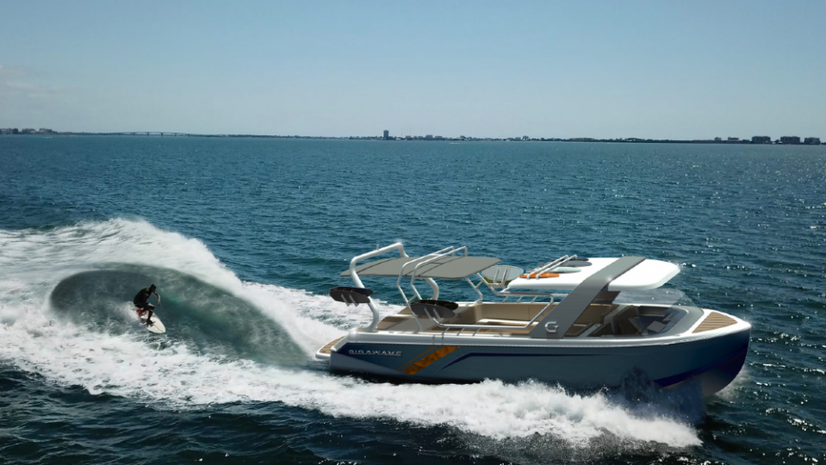
MLR began discussions with a number of groups about a watercraft operator’s certification. All of Minnesota’s neighboring states have instituted watercraft operators permits. The training required for the permit can be done online, and would include rules of the road, safety, etiquette.

Then in 2019 MLR began hearing about a new type of boat and watersport - wakeboarding. In wakeboarding a surfer launches from a platform on the back of the boat while the boat is in motion, usually about 10 knots. They then surf the wake right behind the boat, so close they can talk to riders. No tow rope is required.

The sport is possible due to a marvel of engineering, a hull design, massive engine and adjusted drive train, ballast tanks that can be filled to create extra weight and hydraulic plates that can be extended from the hull to drive the boat deeper into the water - all designed to create bigger and more powerful wakes, some as large as six feet.

Wake surfing is emerging as a popular new water sport. Entire families can participate and the slow speeds mean that injuries are uncommon. Boat dealers and industry note that wakeboard boats are one of the fastest growing segments of new boat sales.

But there are problems with wakeboard boats as well:

- In 2018 a study by University of MN and MN DNR found that because the ballast tanks on wakeboard boats cannot be fully emptied and zebra mussel veligers can survive at high densities and for a long time, wakeboard boats are the highest risk watercraft for AIS transport.
- Lake Associations and shoreline property owners reported that the large, powerful wakes generated by these craft were causing significant erosion of shoreline.
- The large wakes were damaging docks, lifts, boats and other infrastructure,
- The large wakes have knocked down children in the water and washed people off of their docks.
- The prop thrust from these boats was churning up lake bottoms, destroying aquatic plants, reanimating sediments, silting in spawning beds and fueling algal blooms.
- The large wakes caused conflicts with other users, including other boaters, canoists, kayakers, paddle boards and anglers.

On some lakes the negative impacts were so extreme that groups began to call for a ban on these boats. These calls for a statewide ban were growing in volume and gaining traction. The national watersports industry hired lobbyists to fight any attempts to restrict the use of these boats. A big controversy was building in St. Paul, and controversy makes solutions much harder to reach.
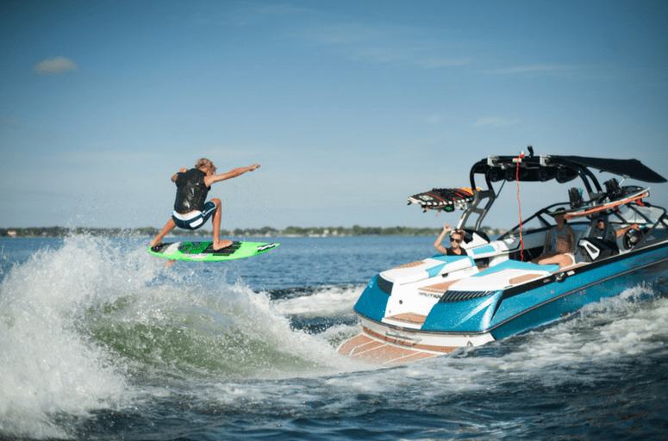
Over the summer of 2019 Minnesota Lakes and Rivers Executive Director Jeff Forester met with angling and sportsmen’s groups, DNR, watersports industry representatives, and lake associations to define the problem. All agreed that if operated inappropriately, all of the negative impacts listed above were concerns.

At one meeting, a boating industry representative said, “It is not the boats that cause problems. It is the operators.”

In that statement MLR saw a solution. We began our work with three primary goals:
- Get the best science on the impacts of boat wakes and prop wash on lake ecology. Use reliable, peer reviewed data to develop best practices,
- Protect the ability of local governments to use regulations to protect local resources,
- Educate boaters in a watercraft operators certification course on these Best Practices so that operators understand, value and protect lake ecology and other user groups.
There are two key questions:
- What is the wake energy of various boats and how long does this energy take to dissipate?
- How deep can the prop thrust of different boats go?

In the summer of 2020 MLR and partner organizations partnered with the University of Minnesota to initiate a CrowdFunding effort to answer these questions. The first phase looked at different styles of enhanced wake watercraft and different runabouts and was estimated to cost $93k. Many lake associations in Minnesota, a few marina owners, a local boat dealer, and lake associations across the country contributed. By September of 2020 the CrowdFunding effort passed the goal and the oldest fluid dynamics lab in the United States, the St. Anthony Falls Lab, began this important research.

A preliminary report of findings is expected this spring. This data will be used to generate best practices for all watercraft with regard to operating depths and distance from shore to avoid causing ecological damage to our lakes.

Over the summer of 2021 MLR will work with MN DNR to design a watercraft operator’s permit course that will include these best practices. We will also include more information on aquatic invasive species, dispel myths and teach boaters how to avoid spreading these species. Other segments of the training could focus more generally on lake ecology, and proper boating etiquette to avoid conflict among user groups.

To date MLR has been reaching out to other groups, including some that have opposed some previous AIS bills, to build a broad cross sector base in support of the research and education. MLR will continue working with our partners to increase the safety and enjoyment of all lake users.

MN Lakes & Rivers Advocates ~ PO Box 22262 ~ St. Paul, MN 55122
www.mnlakesandrivers.org ~ 952-854-1317 ~ judy@mnlakesandrivers.org

